

**ACÁ VA EL NOMBRE DEL DOCUMENTO**

Acá puede ir una descripción breve o información adicional sobre el documento.

**Classical algorithms: searching and sorting.**

**Worksheet 10.1**

**Do the following tasks:**

1. Order these countries from the smallest to the biggest:  
   Colombia Vatican Russia India
2. Order these subjects alphabetically:  
   Mathematics Physics Biology Spanish
3. Find the action movie in this list:  
   Titanic Conjuring ET Transformers

<https://wordwall.net/resource/17175356/warm-up-do-the-following-tasks>

**Worksheet 10.2**

**Match the vocabulary word with the antonym.**

|  |  |  |
| --- | --- | --- |
| **Antonym** | **Antonym** | **Antonym** |
| Abandon | disorder | none |
| Later | whole | output |
| lose | disorganized | length |
|  |  |  |
|  |  |  |
|  |  |  |

1. Search………………. Abandon
2. Sort………………….. disorder
3. Each………………… none
4. Until………………..later
5. Input………………. output
6. Find…………………lose
7. Ordered…………………… disorganized.
8. Height……………………… length
9. Middle…………………………. whole

**Practice more using this link**

<https://wordwall.net/resource/16699961/learning-new-vocabulary-through-antonyms>

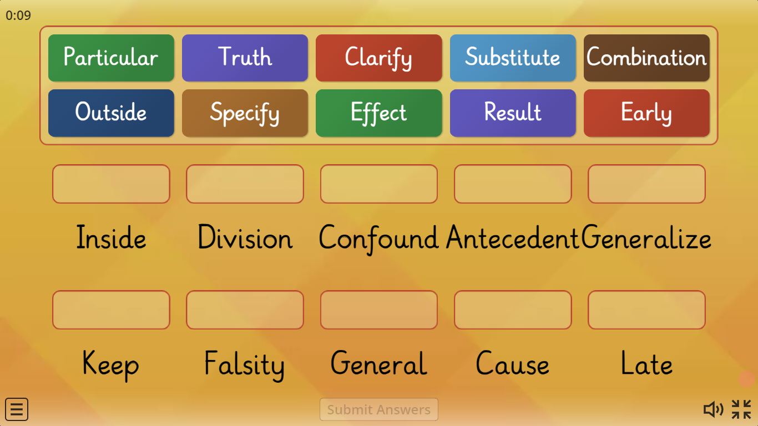

**Worksheet 10.3**

**Reading strategy**

**Watch the video about rereading. Take notes about the most important things.**

<https://www.youtube.com/watch?v=pj_abxp2xIA>

1. Reread understand the ideas ____________________________________________

2._helps me focus ________________________________________________________

**Reading**

**Watch this video that introduces the topic for a better understanding about Algorithms**

[**https://www.youtube.com/watch?v=4VqmGXwpLqc**](https://www.youtube.com/watch?v=4VqmGXwpLqc)

Read the text, and each time you see a **\*stop\*** sign, you need to stop and think whether you understand what you are reading or not. If not, you have to go back and reread.

**Top Algorithms You Really Need To Know**

If you want to become a software engineer, the most basic thing that you have to learn are algorithms and data structures. The more algorithms and data structures you learn, the more useful they will be in your career as a software engineer. To start, let’s learn Search and Sort, two classes of algorithms a programmer can’t live without. **\*stop\***

Searching

There are two categories of *search* algorithms we will study: linear and binary.

Linear search: **busqueda lineal**

*Linear search* algorithms means that the program will look at each item in the line (=input) **until it finds the necessary item**. **\*stop\*** If you have 100 items and you **need to search** for one specific item, then you have to look at every item in the input before you find the necessary item. Linear = simple. **\*stop\*** For example: imagine you want to find your friend Maria in a line of people standing in no particular order. You already know Maria´s appearance, so you have to look at each person, one by one, in sequence, until you recognize Maria. In doing so, you follow the linear search algorithm. **\*stop\***

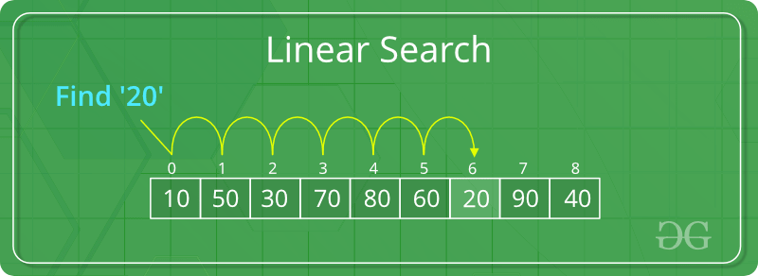

Binary search: segmentation

*Binary search* (binary - “relating to 2 things”) works by dividing the input into two parts until it finds the necessary item. **\*stop\*** One part contains the necessary item and the other part does not. It is faster than linear search, but it only works with **ordered sequences** – and this is very important, because the linear search does not need an ordered sequence. **\*stop\*** For example: imagine you’re want to find your friend John (who is 170 cm tall) in a **line of people ordered** by height from left to right, shortest to tallest. It is a very long line, and you do not have time to go one-by-one like with the linear search. What can you do? Use binary search. You select the person in the middle of the line, and measure their height. The person is 165 cm tall. You immediately know that this person, and all the people on their left, is not John. **\*stop\*** Next, you turn your attention to the people on the right and **select the middle person again**. The person is 172 cm tall. You can eliminate that person and all the people on the right. And so on, until you find the person who is 170 cm tall – and that is John. In doing so, you follow the binary search algorithm. **\*stop\***

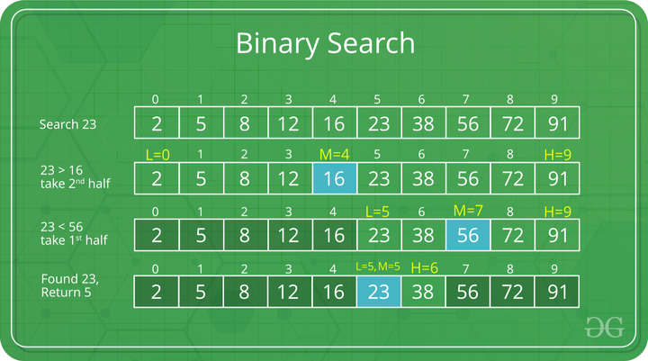

Sorting: classify

Sorting is a synonym of ordering. It is one of the most common programming tasks. We will look at one type of sorting - MergeSort. **\*stop\***

MergeSort:

Imagine you have an unordered group of people, and you need to order them by height. First, you divide the group in two; then **you divide each of the two groups in two again**, and so on – until you have individuals. **\*stop\*** Second, **you put individuals in pairs**; you put the taller person to the right**, until you organize** all the pairs. Next, you put pairs in groups of four, and order them. **\*stop\***After that, you put the groups of four into groups of eight. And so on, until you have a **complete line of people ordered by heigh**t. By doing so, you follow the MergeSort algorithm. **\*stop\***

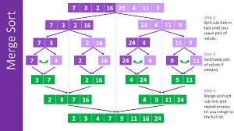

**Worksheet 10.4**

**Read the following situations and figure out which of the three algorithms you have to use in each situation**: ***linear search, binary search or Merge Sort.***

1. There are 30 students in class. You need them to stand in a line according to their age, from the youngest to the oldest, from right to left. Is *Merge Sort*
2. You have 15 circles that are ordered in the line from the smallest (2 cm diameter) to the biggest (50 cm diameter). You need to find the circle that is 22 cm in diameter. *binary search*
3. You are in a supermarket, and your mother asked you to buy coffee that is called “Super Delicious Coffee”. Lineal search
4. You are in the library, in the section of “Original English Literature”. There are 100 books that are ordered alphabetically. You need to find “Harry Potter and the Order of Phoenix”. *binary search*
5. There are 10 people in a bank. The oldest people have a priority. You need to make a line of people taking into account the priority: oldest person first, youngest person last. Merge sort

**Worksheet 10.5**

**Answer the following questions:**

1. Entiendo en qué consiste la estrategia de “rereading”.

Si No De pronto

2. La estrategia “reread” me ayuda a concentrarme más cuando leo un texto.

**Si** No De pronto

3. Cuando vuelvo a leer, entiendo mejor el texto.

**Si** No De pronto